UN Trust Fund Cycle 27 Project Concept Application
Grants Management System (GMS) Related Instructions
&
Frequently Asked Questions

CONTENT
1. HOW TO REGISTER YOUR PROFILE IN THE SYSTEM 2
2. HOW TO CHANGE YOUR PASSWORD 3
3. APPLICANT DASHBOARD 4
4. APPLICATION DETAILS 6
4.1. Section 1: Organization Profile 9
4.2. Section 2: Project Profile 10
4.3. Section 3: Project Concept 16
5. GMS HELP DESK 18

HOW TO REGISTER YOUR PROFILE IN THE SYSTEM
- Go to the Grants Management System (GMS): https://grants.untf.unwomen.org/Public/Home and click on Login.
- Click on Sign Up.
- Enter your valid Email ID and click on Send Verification Code.
- Enter the Verification Code received in your email and Click on Verify code button.
- Enter following details and click on Create:
  - New Password
  - Confirm New Password
  - First Name
  - Last Name
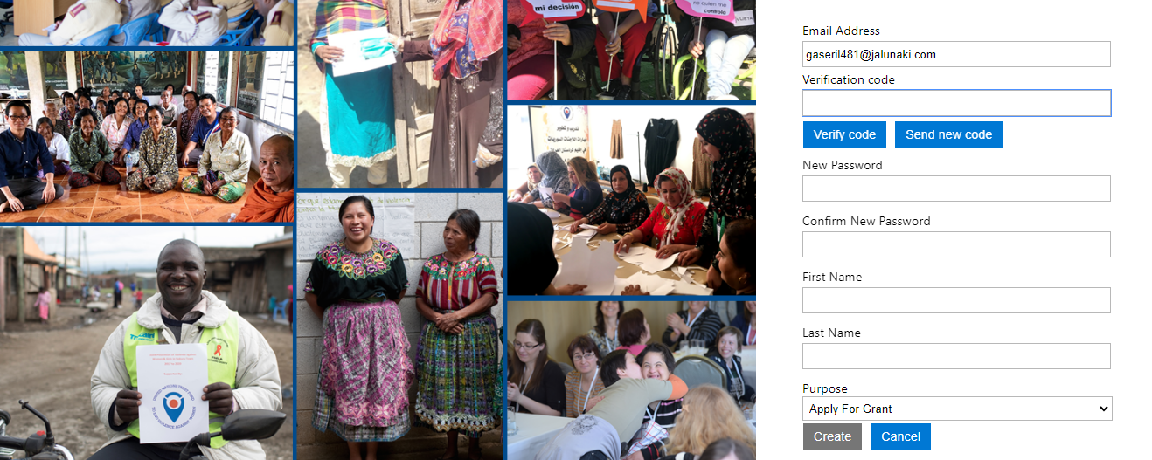
  - Purpose: Select Apply for Grant

- When in the Registration page, enter all User Profile details.
Note: once you select your preferred language in the User Profile, you will not be able to switch to another language.
Note: all fields marked with an asterisk * are Mandatory.
- Click on Submit.

HOW TO CHANGE YOUR PASSWORD
- From the Applicant Dashboard click on your name and then, click on Change Password.

- Insert your email and click on Send Verification Code.
- Enter the Verification Code received in your email and click on Verify code button.
- Click on Continue.

- Insert your New Password and click on Continue.
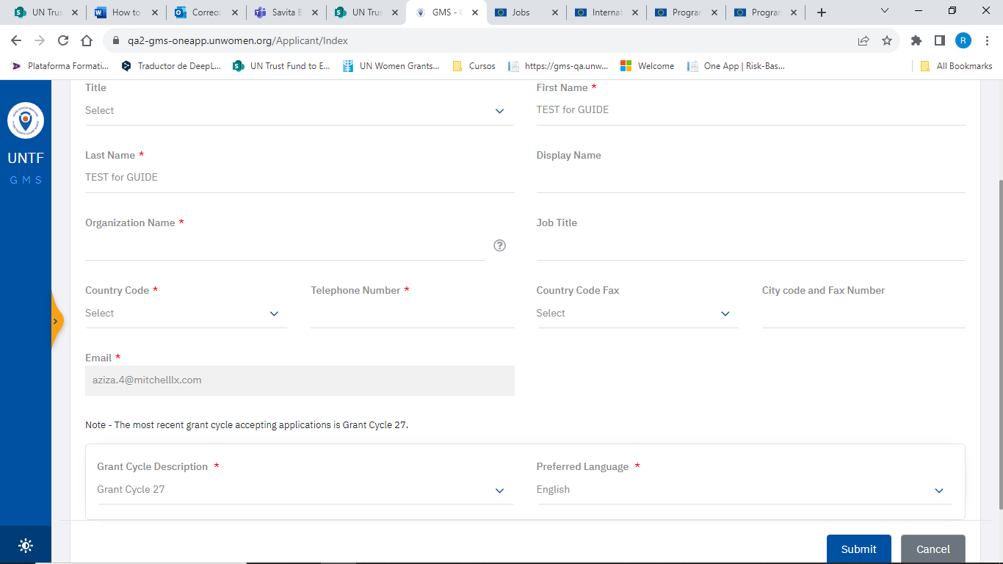
- You will be re-directed to the Applicant Dashboard.

APPLICANT DASHBOARD
There are two main buttons in the Applicant Dashboard:
- Inspect Application: It can be clicked at any time and it will flag which tabs of your application contain error.
- Submit Application: It will only be enabled if no errors are displayed from Inspect button.
Note: submit your application as soon as it is completed! Do no wait until the last minute.
- After your application is successfully submitted, the status will change to “Submitted” and you will receive an automatic email confirming your submission.
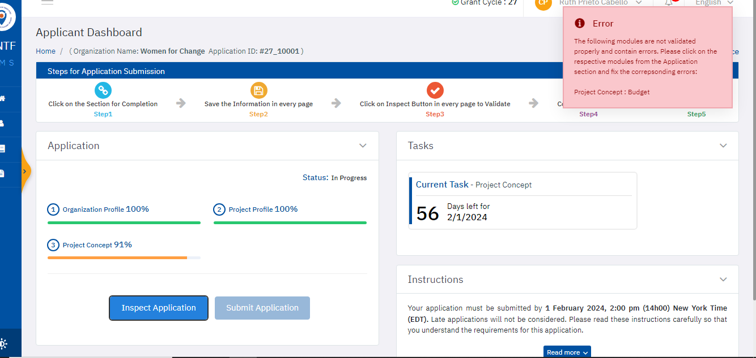

Note: If you did not receive the confirmation email from GMS, please reach out to the Help Desk at: untfgms@unwomen.org
- It is not possible to make any changes after an application has been submitted.
- You can print your application by clicking on the Download PDF button on the homepage.

There are 3 sections to be completed as shown in the Applicant Dashboard:
- You should complete your application as follows: 1. Organization Profile, then 2. Project Profile, and finally 3. Project Concept.
- Each section contains several tabs for completion: 1. Organization Profile (5 tabs), 2. Project Profile (5 tabs) and 3. Project Concept (4 tabs).
- 2. Project Profile – Beneficiaries and Partners tab includes 2 subtabs for completion: Primary Beneficiaries and Partners and Secondary Beneficiaries and Partners.
Note: You must click on Save button first and then on Inspect for each Tab/Subtab.
Your progress for each section can be displayed in 3 different colors:
- Red: Indicates that you visited the Tab(s), but you did not Save any data.
- Orange: Indicates that you entered and Saved data. However, did not complete the entire section.
- Green: Indicates that you entered and Saved data for each required question. It does not imply that your application is fully completed. In order for your application to be considered as fully completed, you must ensure that the information you entered has been properly Validated and it does not contain errors.
Note: Before submitting your application, please remember to click on Inspect button.

APPLICATION DETAILS
- To navigate between sections, click on “Change the Section” link located on the top right corner of the page.
- Please note that all fields marked with an asterisk * are Mandatory.
- All questions with ? contain some instructions. For further explanation, click on the icon.
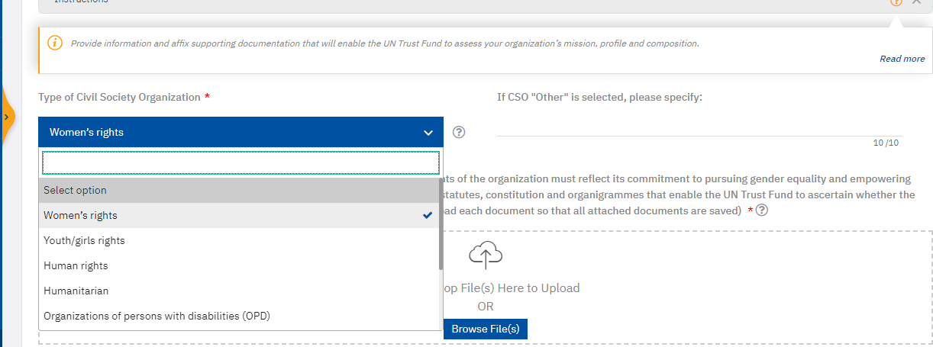
- Please make sure to scroll through all possible options before selecting your answer:

- There is a Save button and Inspect button in each tab/subtab:
Save: Allows you to save your data at any time, even when the tab is incomplete, or an attachment is missing. You can save your progress and return to continue later.
Note: Please remember to save your application frequently to avoid missing data.
Inspect: Allows you to check the errors in your current tab at any time, so you can fix them before submission:
  - If the Inspect button is red, that means there are some errors in the tab. Please click on the Inspect button and you will be able to see the exact error message.
  - If the Inspect button is green, that means your current tab is completed correctly.
- Sections in the navigation bar with a red circle signify that there are mandatory questions that are either unanswered or answered incorrectly in that particular section.
- The number in the red circle indicates the number of questions unanswered or answered incorrectly. You may click on the Inspect to investigate and address the questions that need to be filled out in order to complete a particular section.

Section 1: Organization Profile
- ORGANIZATION CONTACTS
If the “Inspect” button is in red, click on it to see the exact errors. It is likely:
- You didn’t enter at least two contacts.
- The E-mail address is not valid, please check if there is any space “ ” when you enter the email address.
- You added a third contact but did not complete all required fields.

- ORGANIZATION CAPACITY and MANDATORY REQUIREMENTS
- Please click on Save after you upload each individual document so that all attached documents are saved. Otherwise, you will lose the previous document every time you upload a new one.
- Your files cannot exceed 50 MB in size.

Section 2: Project Profile
- PROJECT OVERVIEW
Project start date: The estimated start date cannot be set before 1 August 2024.

- PROJECT CONTACTS
You need to select from the contacts created under Organization Contacts tab.
Note: You cannot add new contacts in this tab. If needed, go back to Organization contacts tab and revise (add, edit or delete) the contact information in order to select it in Project Contacts.

- BENEFICIARIES AND PARTNERS
Please note that there are two subtabs in the Beneficiaries and Partners tab for your completion.
Note: Remember to click on Save and Inspect in both subtabs.
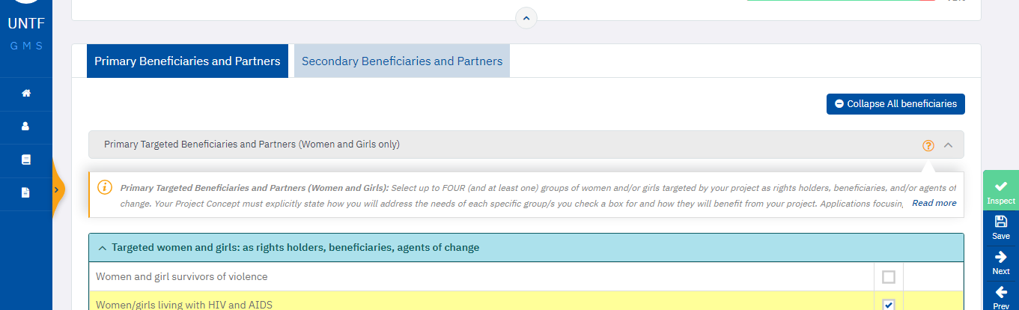

Section 3: Project Concept
- BUDGET
If the Inspect button is red, click on it to see the exact errors. It is likely:
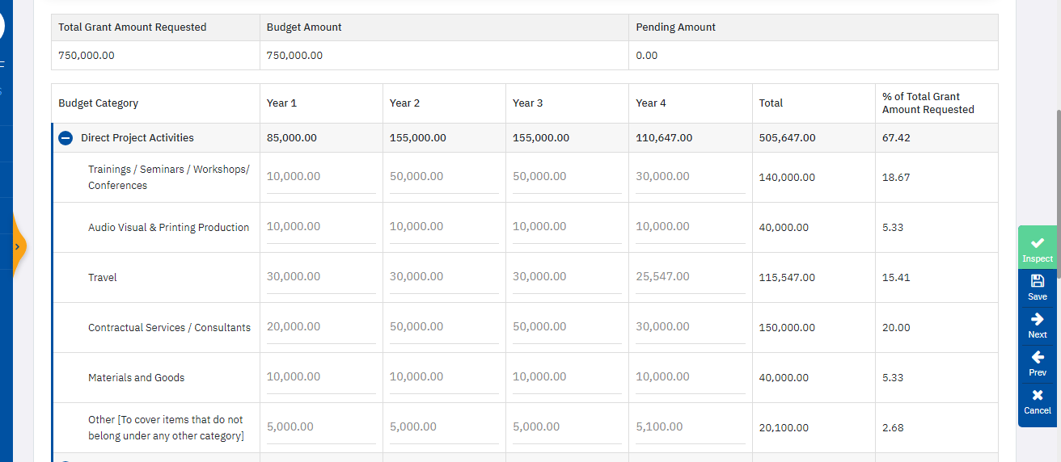
- You budgeted more OR less than your total requested amount: Pending Amount must be 0:

- If you need to change the Total Grant Amount Requested (highlighted in yellow), go back to section 2. Project Profile – Project Overview to update the field: Total amount requested from the UN Trust Fund (in US dollars).
- If all data seems to be correct but the Inspect button is still red, please click on Save button.
- Please take into account that under Management Activities various budget lines are mandatory.
- Note: If you did not complete the questions on Project Duration and Grant Amount Requested under Project Overview, the Budget tab will not be available.
- Please always refer to the Annex 3: Budget Summary & Budget Guidelines document for more information and guidance.

GMS HELP DESK
- If you have any further questions or concerns regarding completion and submission of your application in GMS, please contact the HELP DESK at untfgms@unwomen.org with subject [Application Help: Your Organization Name and Application ID number] . We will respond to your questions within 24 hours during work hours Monday - Friday. 25 December 2023 and 1 January 2024 are official holidays.

